**CHIRANJIT CHAKMA**

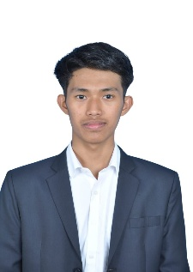Puttarachappu VM Parvathamma, 437, Block A & B  
Vishwamanava Double Road, Kuvempu Nagar  
Mysuru, Karnataka – 570023  
📞 +91-9606895445  
📧 chiranjitc184@gmail.com

## Objective

Motivated and tech-curious BSc student with a strong interest in cybersecurity and digital innovation. Skilled in using advanced AI tools like ChatGPT, DeepSeek, Grok Beta, and Dest to assist in game and app development. Seeking to pursue a Master’s in Cybersecurity in Australia to build a career in ethical hacking, data protection, and secure systems.

## Education

Bachelor of Science (BSc) – PMCS (Physics, Mathematics, Computer Science)  
Amrita Vishwa Vidyapeetham, Mysuru  
2024 – Present  
- Current Semester: 3rd  
- CGPA (2st Semester): 6.8

Pre-University Course (PUC) – Science  
Learners PU College, Mysuru  
2021 – 2024  
- Percentage: 80.6%

10th Standard  
Mahabodhi School, Mysuru  
Year of Passing: 2021  
- Percentage: 76.8%

## Technical Skills

- AI-Powered Coding: ChatGPT, DeepSeek, Grok Beta, Dest  
- Web/App Development: HTML, CSS, Dart (basic)  
- Cybersecurity Exposure: Kali Linux (beginner), Network safety tools  
- Systems & Tools: Windows, Logical Testing  
- Other Strengths: Fast learning, creative use of AI tools, design sense

## Project

Social Media App Collaboration (2025 – Present)  
- Collaborating on the development of a social media application by testing features, identifying bugs, and providing design feedback.  
- Suggested UI/UX improvements, layout themes, and user-focused design changes.  
- Helped improve functionality across devices and ensure a smooth user experience.  
- Learned the fundamentals of real-world app development, teamwork, and QA testing.

## Strengths

- Quick learner and highly adaptable  
- Passionate about cybersecurity and ethical hacking  
- Strong team collaboration and communication  
- Practical experience using AI tools in projects

## Languages Known

- English (speaking & writing)  
- Hindi(speaking)

## Declaration

I hereby declare that the above information is true and correct to the best of my knowledge and belief.

Date: 21/07/2025

Place: Mysuru

Signature  
Chiranjit Chakma

|  |  |
| --- | --- |
|  |  |